**DAY 6:**

**JENKINS:**

Jenkins is an open-source automation server used for **Continuous Integration (CI) and Continuous Deployment (CD)**. It helps automate software development processes, including **building, testing, and deploying applications**.

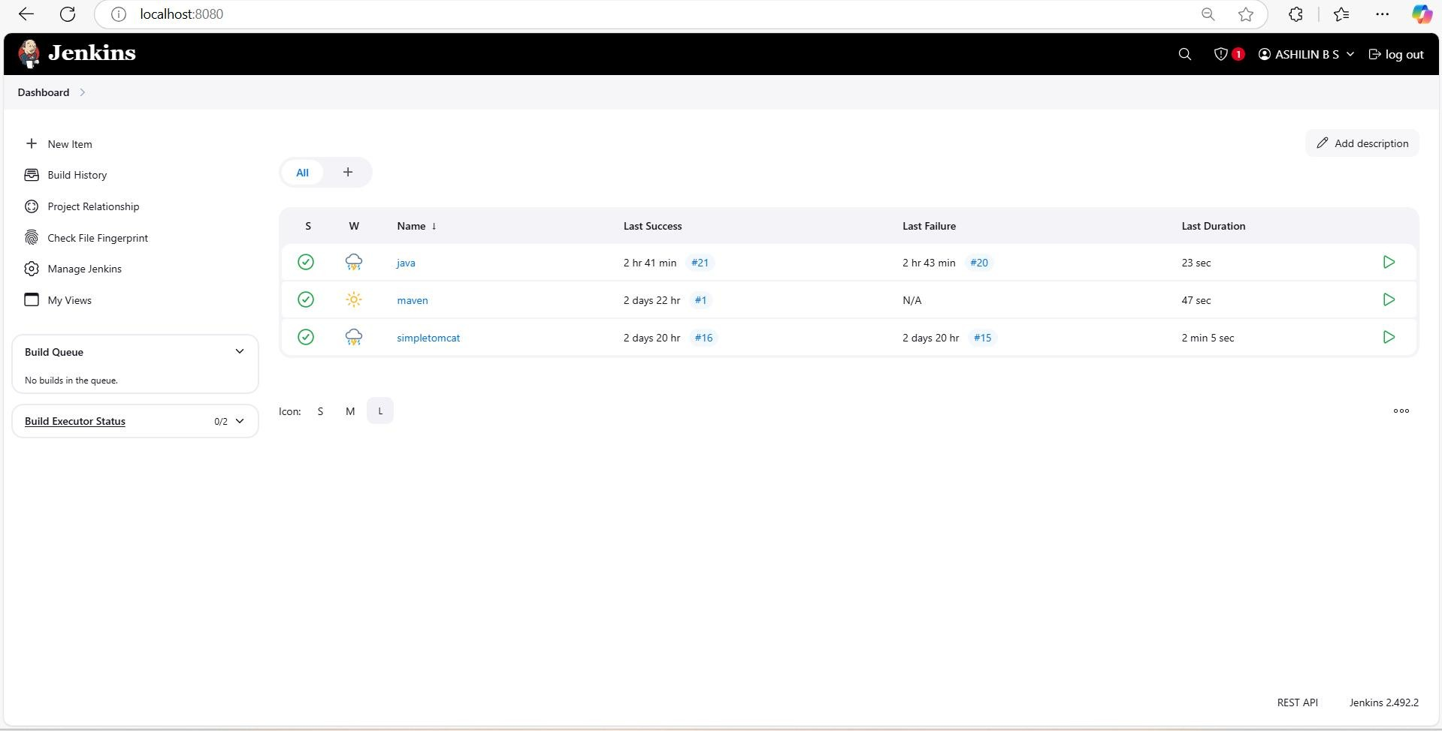

**JENKINS PIPELINE:**

A **Jenkins Pipeline** is a set of automated steps that define how software is built, tested, and deployed. It is written as code in a **Jenkinsfile** and helps implement **Continuous Integration (CI) and Continuous Deployment (CD).**

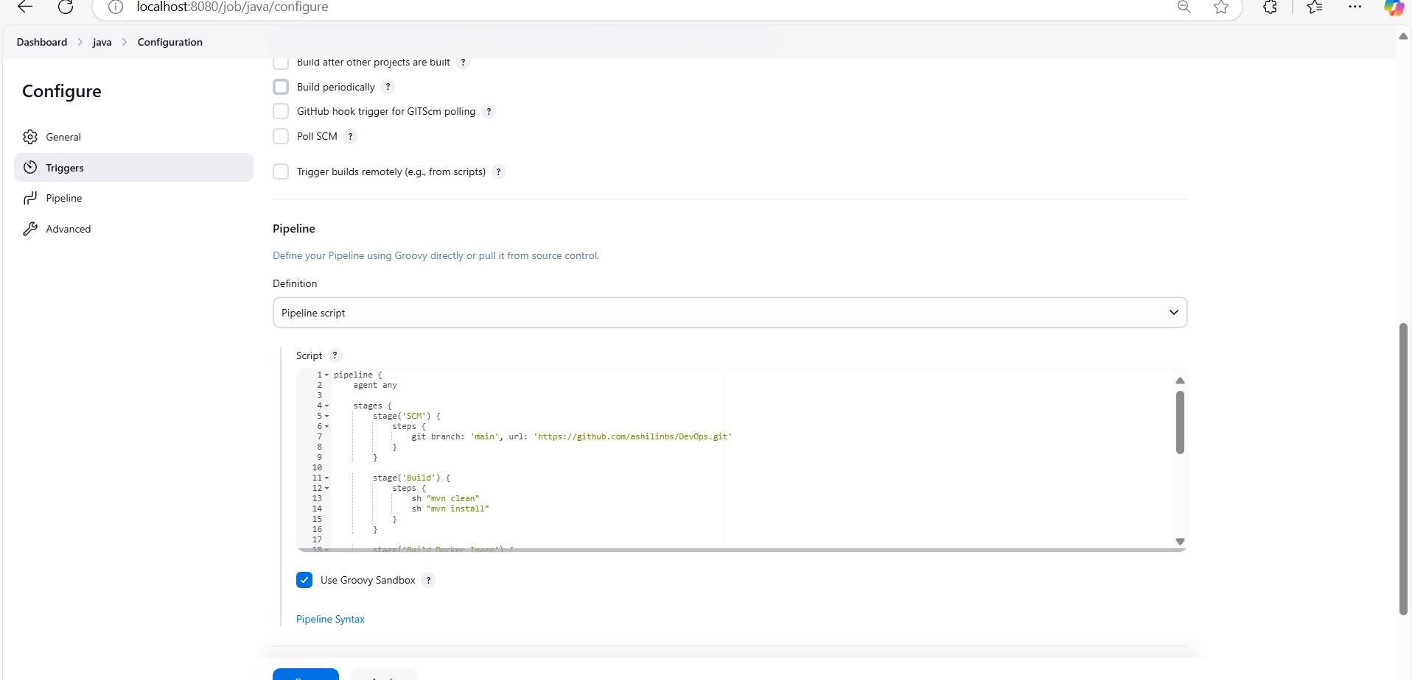

**KUBERNETES DEPLOYMENT:**

apiVersion: apps/v1 kind: Deployment metadata: name: my-deploy labels:

apptype: web-backend # Ensure this matches Service selector

spec: replicas: 4 selector: matchLabels: apptype: web-backend # Ensure this matches Service selector strategy: type: RollingUpdate

template:

metadata:

labels:

apptype: web-backend # Ensure this matches Service selector

spec: containers:

* name: my-app

image: ashilin20/app:latest ports:

* containerPort: 5050

---

apiVersion: v1 kind: Service metadata: name: my-service labels:

apptype: web-backend # Make labels consistent

spec: type: NodePort ports:

* targetPort: 8080 port: 5050 nodePort: 30001

PIPELINE SCRIPT:

pipeline { agent any

stages {

stage('SCM') {

steps {

git branch: 'main', url: 'https://github.com/ashilinbs/DevOps.git'

}

}

stage('Build') {

steps {

sh "mvn clean"

sh "mvn install"

}

}

stage('Build Docker Image') {

steps {

script {

sh 'docker build -t ashilin20/app .'

}

}

}

stage('Push to Docker Hub') {

steps { script {

withDockerRegistry(credentialsId: 'cur', url:

'https://index.docker.io/v1/') {

sh 'docker push ashilin20/app'

}

}

}

}

}

}

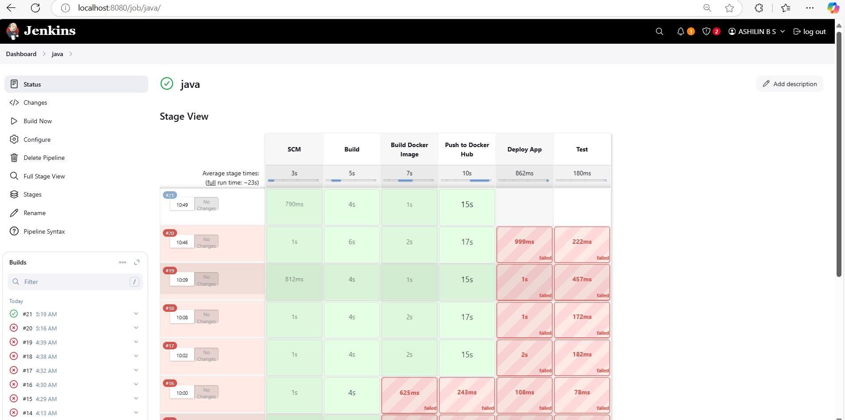

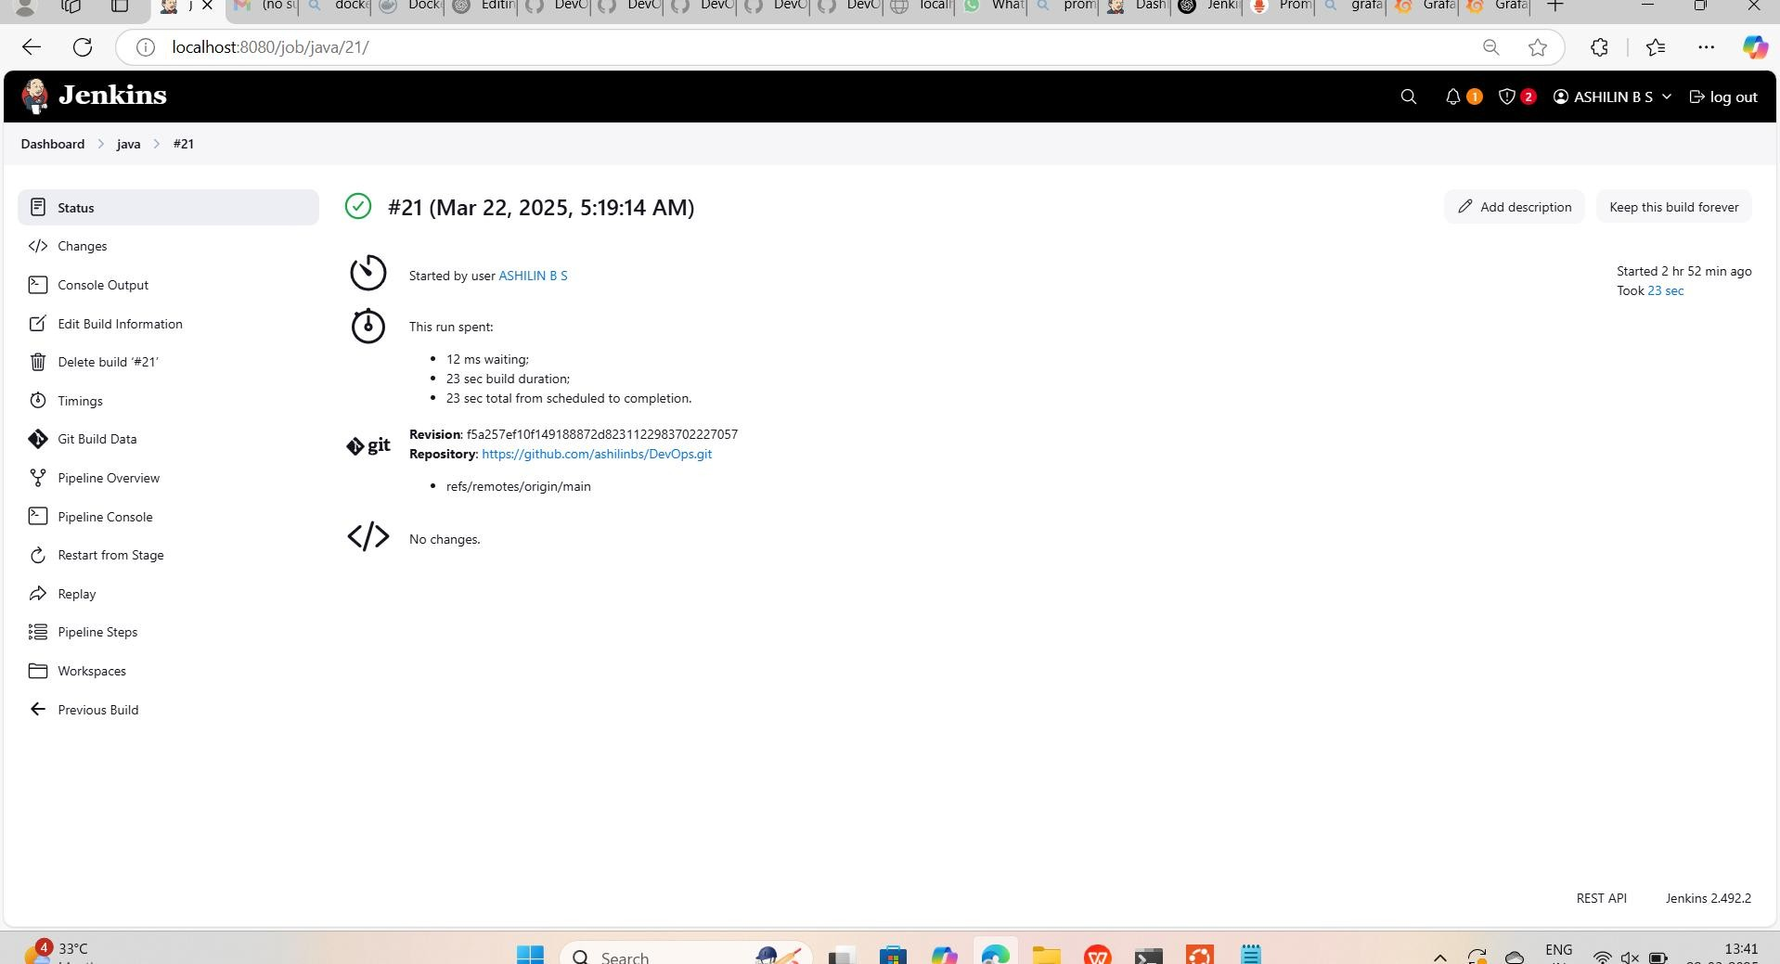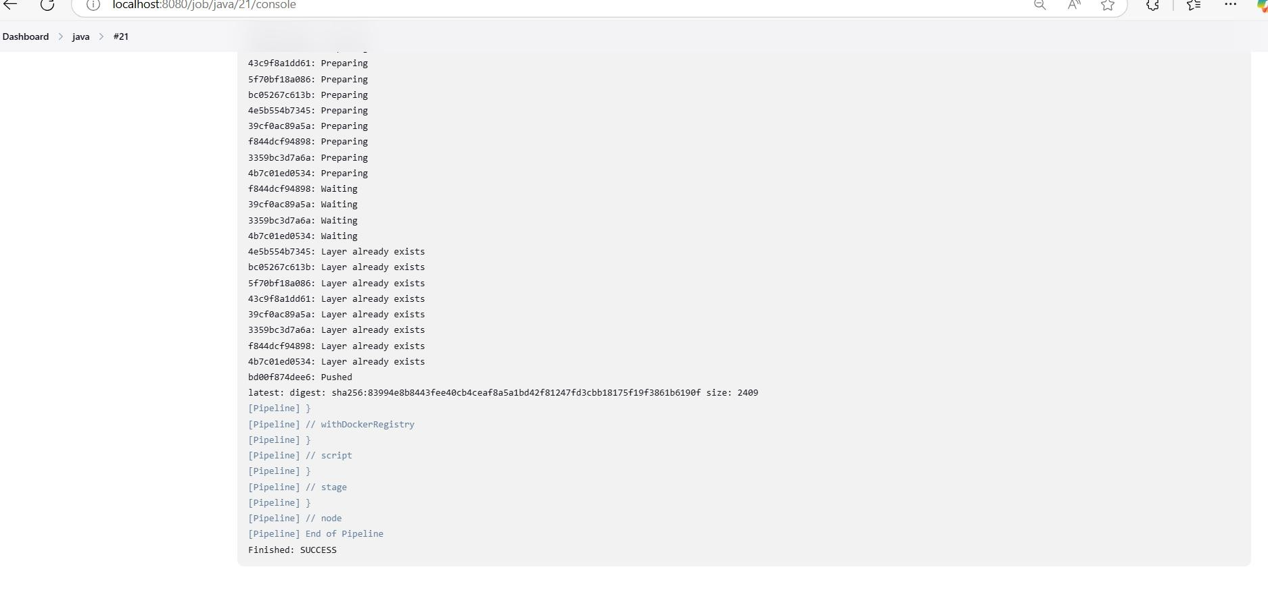

MINIKUBE COMMANDS:

**Start & Stop Minikube**

sh CopyEdit

minikube start # Start Minikube cluster

minikube start --driver=docker # Start with Docker driver

minikube status # Check cluster status minikube stop # Stop Minikube minikube delete # Delete the cluster

**Configure Minikube** sh

CopyEdit

minikube config set memory 4096 # Set memory to 4GB minikube config set cpus 2

OUTPUT:

